Computer Workshop 7: Linear models with a multiple predictors
Roos & Pinard
Last updated: 2024-08-21
Table of Contents

Workshop Structure
As always, we are using the workflow below to structure the workshops:
- Formulate a research question.
- Perform exploratory data analysis.
- Identify any hidden assumptions.
- Fit an appropriate model [Focus of today].
- Diagnose the model and check assumptions.
- Summarise the results.
- Interpret and provide inferences.
A slight tweak today though, is that we’re going to use the same dataset to run two models. The dataset is the same one you used in the first week of the course when we were looking at flat prices in Aberdeen.
The two models we’re going to run are 1) a model that attempts to predict rent price as accurately as possible, and 2) a model that attempts to understand the causal effect that the square meters of a property has on on rent price.
The reason for doing this is that we want to make clear that models can have different purposes, depending on our needs. Want a fancy AI machine learning model? Sure, easy. But we can use the exact same machinery to also build a that understands causal effects.

Predictive modelling
We’ll start with the predictive model, because they’re much easier to do (they don’t require much thinking, just don’t say that to any Machine Learning folk).

1. Formulate a Research Question
Fairly simple this time around. We just want to predict rent price. We don’t care why a flat is more less expensive. We just want to be able to predict it accurately.

2. Perform Exploratory Data Analysis
As usual, carry out a quick data exploration looking for any mistakes. Keep in mind that you have a link to each property, so if you spot something that looks weird, you can resolve it yourself (a rare luxury!).

3. Identify Any Hidden Assumptions
Even though our aim here is pure prediction, we still want to think about hidden assumptions - we don’t want to make predictions for flawed data. Spend a couple of minutes trying to identify any issues (or limitations, e.g. can you predict house prices in London from this data?).

4. Fit an appropriate model.
One of the things that makes predictive modelling so easy is that we can just throw all explanatory variables we have into the model with very little thought for what the underlying relationships would be. However, in the interest of keeping this first part of the workshop manageable, we’ll specify that the model we want to run includes the following explanatory variables:
- sqmt - the size of the property in square meters.
- rooms - the total number of rooms in the property (the sum of bedrooms and living rooms)
- epc - the energy performance of the property (categorical with levels A to G, note no A properties are present in the data)
- tax - the council tax band of the property based on assumed value of the property in 1991.
Notice that we’re going to use rooms in the model, but you don’t have this in your dataset. You’ll need to create this new variable in your dataset. Try to figure out the code on your own but keep in mind that rooms is just beds added together with living (bedrooms and living rooms).
The statistical notation for this model becomes a bit of a nightmare, simply because of how many levels there are in epc and tax but here’s what it looks like:
$price_{i}∼Normal\left(μ_{i},σ\right)$
$μ_{i}=β_{0}+β_{1}×sqmt_{i}+β_{2}×rooms_{i}+β_{3}×epcC_{i}+$ $β_{4}×epcD_{i}+β_{5}×epcD_{i}+β_{6}×epcE_{i}+β_{7}×epcF_{i}+$ $β_{8}×epcG_{i}+β_{9}×taxB_{i}+β_{10}×taxC_{i}+β_{11}×taxD_{i}+$ $β_{12}×taxE_{i}+β_{13}×taxF_{i}+β_{14}×taxG_{i}$
where:
- $β_{0}$ is the intercept, representing a property with zero square meters, zero rooms, an EPC of B and a tax band of A.
- $β_{1}$ is the slope for each additional square meter
- $β_{2}$ is the slope for each additional room
- $β_{3,...,8}$ are the differences for each EPC relative to $β_{0}$
- $β_{9,...,14}$ are the differences for each council tax band relative to $β_{0}$
Like I said, a nightmare. You can see here why discretising (or creating groups) can be a problem in models. Instead of using a spectrum (or continuous value) for, e.g. energy efficiency, we’re left with a model that now needs to estimate 14 parameters, rather than just four if we had continuous variables for EPC and council tax. As a general tip when you get to your honours projects and beyond, avoid “dichotomania” (or creating categoricals/dichotomies for data that’s really a contuinuous spectrum) for your own sanity if nothing else.
Regardless, we can run this model fairly easily in R,
rent_mod <- lm(price ~ sqmt + rooms + epc + tax, data = abdn)
Having run the model, let’s see what the parameters $β_{0}$ and $β_{1}$ have been estimated as, using summary():
summary(rent_mod)
A whole bunch of parameters have now been estimated. Again, avoid dichotomania! It makes everyone’s life so much harder. We don’t have a choice here. We’re stuck with EPC values of “B”, “C”, “D”, “E”, “F” and blah, blah blah. Really, just avoid discretisation in your own work and life. You’ll be happier for it (and also less bigoted a lot of the time :D).

5. Diagnose the model and check assumptions.
In previous workshops, we’ve left assumption checks for the Friday session, but hopefully you’ve gained enough confidence now to do this relatively quickly.
Let’s do a quick check now:
par(mfrow = c(2,2))
plot(rent_mod)
## Warning: not plotting observations with leverage one:
## 88
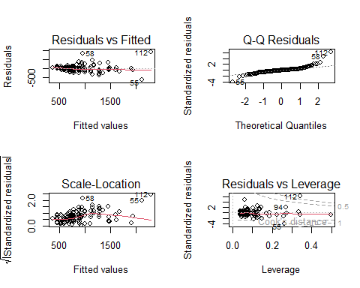
par(mfrow = c(1,1))

Question Set One
- Do you see any assumptions that are likely broken in the Residuals vs Fitted and Scale-Location plots?
- If so, what is the consequence of violating this assumptions?
- Do you see any assumptions that are likely broken in the Q-Q Residuals plot?
- Are there any observations that are having a disproportionate affect on the model?
- If there are any such observations, what should we do about them (if in doubt, ask a member of staff)?

6. Summarise the results.
As usual, pull up the summary table:
summary(rent_mod)
Pay attention to the Estimate for sqmt; the model seems to be predicting that adding an extra 1 square meter to a property only increases the rent by about £0.10. Seems a bit weird. We’ll come back to this after we run the causal version of this model.
Given the number of explanatory variables we have in our predictive model, we’ll use ggeffects to do the plotting but you can absolutely do this by hand.
library(ggeffects)
## Warning: package 'ggeffects' was built under R version 4.3.3
Then ask ggeffects to predict rabbit weight for each of our mongoose categories:
preds <- ggpredict(rent_mod)
Now we just need to plot it:
plot(preds)
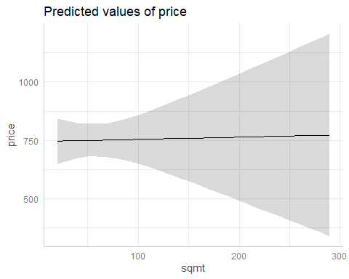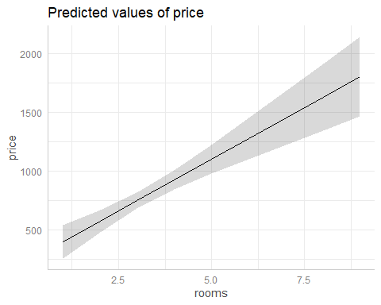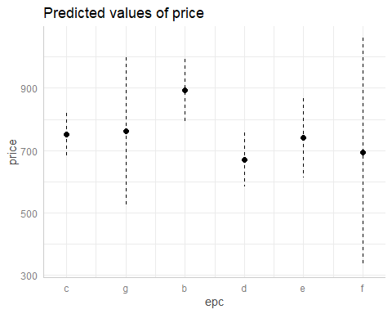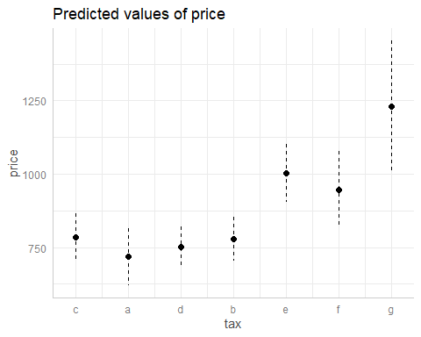

Question Set Five
- Can we identify any causal relationships from this model (e.g. “If you increase the square meters of a property by 10 meters squared, it will cause the rent to increase by X”)?
- Why might the relationship for sqmt be a mostly flat line?
- Go to the letting agency website, ASPC, and find a recently listed rental property which has all of the explanatory variables you need. Using your selected property, see how well your model predicts the rent. You’re also welcome to use your own flat if you know (or can guess) how many square meters it has, what the EPC rating is, and which tax band it falls in.
If you want to see how this kind of model could be translated into something you might see online with a sales pitch like “We’re using the most advanced Generative Artificial Intelligence to predict how much rent you should be asking for”, see here. This is a little toy website I made (entirely in R) just to show you a slightly glossier version of your model. There are two important things to note; 1) I think there’s a decent chance the website will crash if lots of people try to use it at the same time, and 2) I include another model that deals with space - i.e. certain areas in Aberdeen are more expensive than others. One assumption we’re likely to break here is the assumption of independent errors, and including space in the model helps to account for that (this is the “Fancy model” on the site).

Causal modelling

1. Formulate a Research Question
We’re now going to switch over to causal modelling using the same dataset, hopefully, to really hammer home to difference in the two approaches. Our research question is going to be to understand the causal effect of square meters on rent price, or “what is the causal effect of the size of a rental property, in square meters, on the listed rental price?”.
Because we’ve already done an EDA and thought about hidden assumptions, we can move on to fitting the model, but before we do that, we now have an extra step.

Extra: Creating a DAG
Because our question is causal, we can’t just use the approach we did above and throw everything into the model and read off every parameter estimate as being causal. Instead, we need to think about confounding and how to responsibly deal with that in our model. One of the least technical ways of doing this is to create a Directed Acylic Graph (or DAG). This can often be a pretty laborious process, e.g. creating a DAG in powerpoint, but thankfully there’s a much easier way to do this in R using the package we’ve used previously - performance.
The function we’ll be using from performance is called check_dag(). The way the function works is that we specify what we believe (or assume) the causal relationships are. For instance, if we think rent is caused by a combination of rooms, square meters, tax band and EPC, then we would convert this to Rent ~ Rooms + Sqmt + Tax + EPC (note that we don’t need to use the same variable names as in our dataset - these can be called anything, just avoid spaces, e.g. Aberdeen Rent ~ Rooms where the space between Aberdeen and Rent will cause problems).
Having done that, we now just go through what might cause the other variables, for instance the number of rooms you can have in a flat is clearly caused by how many square meters there are, so Rooms ~ Sqmt, and so on.
The final part we need to complete is to define what our response variable is (called “outcome” by performance) and what our explanatory variable is (called “exposure”). This defines our initial model, which in this case would be: Rent ~ Sqmt.
Here’s what your code might look like (but note that your DAG might look different from mine, e.g. maybe you don’t agree with me that EPC is caused by the size of a property):
library(performance)
## Warning: package 'performance' was built under R version 4.3.3
rent_dag <- check_dag(
Rent ~ Rooms + Sqmt + Tax + EPC,
Rooms ~ Sqmt,
EPC ~ Sqmt,
TAX ~ Sqmt,
exposure = "Sqmt",
outcome = "Rent"
)
Once we’re happy that we have a DAG that seems sensible, we can then plot it:
plot(rent_dag)
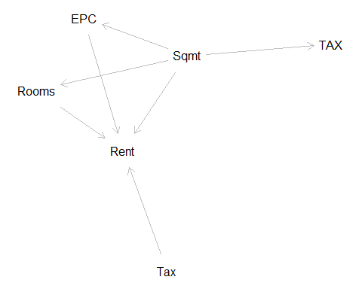
And we can use it to identify which model we should run to answer our research question:
rent_dag
This tells us that to estimate for the direct effect of Sqmt on Rent, we would also need to include EPC and Rooms, but we aren’t interested in just the direct effect, we want to understand what would happen to Rent if we increased a property by 10 square meters, so we want the total effects. For that, check_dag() has suggested that the initial model is correctly specified, where our initial model was Rent ~ Sqmt.

4. Fit an appropriate model.
Let’s run that model:
rent_causal_mod <- lm(price ~ sqmt, data = abdn)

5. Diagnose the model and check assumptions.
And we can do a quick check of the assumptions related to the model residuals:
par(mfrow = c(2,2))
plot(rent_causal_mod)
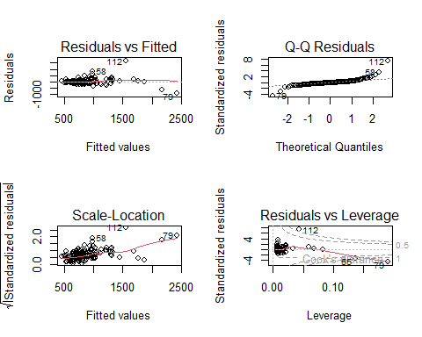
par(mfrow = c(1,1))
We have a fairly similar looking set of plots compared to our first model. The problematic observations this time, though, are rows 112, 79 and 55. As above we have to make a decision. Either we remove these observations from the data and rerun the model, or we carefully caveat our results to indicate that our estimates may be biased. The choice is entirely yours to make, though personally, I prefer not to remove data just because the model struggles to understand them. After all, those data points aren’t “wrong”, they’re just showing the limitations of the model.

6. Summarise the results.
The technical steps are exactly the same as for the predictive model. Get the model summary:
summary(rent_causal_mod)
And plot:
fake <- data.frame(
sqmt = seq(from = min(abdn$sqmt), to = max(abdn$sqmt), length.out = 10)
)
preds <- predict(rent_causal_mod, newdata = fake, se.fit = TRUE)
fake$fit <- preds$fit
fake$low <- preds$fit - preds$se.fit * 1.96
fake$upp <- preds$fit + preds$se.fit * 1.96
ggplot(fake) +
geom_ribbon(aes(x = sqmt, ymin = low, ymax = upp), fill = "lightgrey", alpha = 0.7) +
geom_line(aes(x = sqmt, y = fit)) +
labs(x = "Square meters of property",
y = "Predicted rent") +
theme_bw()
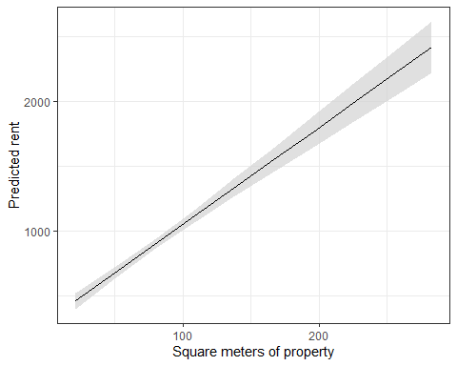
So what we learn is that the average rental property in Aberdeen starts at a baseline of roughly £305 but for every additional meter square “added” the rent increases by roughly £7.50. So long as we assume that our DAG is accurate, this £7.50 increase is the causal effect of square meters on rent.
Compare that with our predictive model that found “adding” an extra square meter to a property would increase the price by £0.10. Clearly that was never going to be the actual causal effect; it’s confounded. But that didn’t matter because our aim was to make a predictive model, not to understand the causal effect.

What is the causal effect of EPC on price?
Repeat the above process, but where our research question is focussed on understanding the causal effect of EPC on price.

Assumption table
Assumption | Description | Example of Violation
1. Validity | The data is able to answer the research question effectively. | Using IQ to measure overall intelligence (what does IQ even measure?).
2. Representativeness | The data reflects the population or group being studied. | Using survey data from a rural area to draw conclusions about an urban population.
3. Additivity | Effects of predictors are additive and there are no interactions between them. | Assuming that study hours and sleep hours independently affect exam scores without considering their combined effect (imagine a Venn diagram with study and sleep overlapping).
4. Linearity | The relationship between predictors and the outcome is linear. | Assuming plant growth will continue to increase indefinitely without ever levelling out.
5. Independence of Errors | Observations are independent of each other. (Related to residual errors.) | If modelling height, the data come from the same group of children over time.
6. Equal Variance of Errors | Residuals have constant variance across all levels of predictors (“homoscedasticity”). (Related to residual errors.) | If modelling income, variability in salaries is not the same across all levels of a company’s hierarchy.
7. Normality of Errors | Residuals should be normally distributed. (Related to residual errors.) | If modelling income, the presence of any extremely wealthy individuals will be hard for the model to understand and explain.

